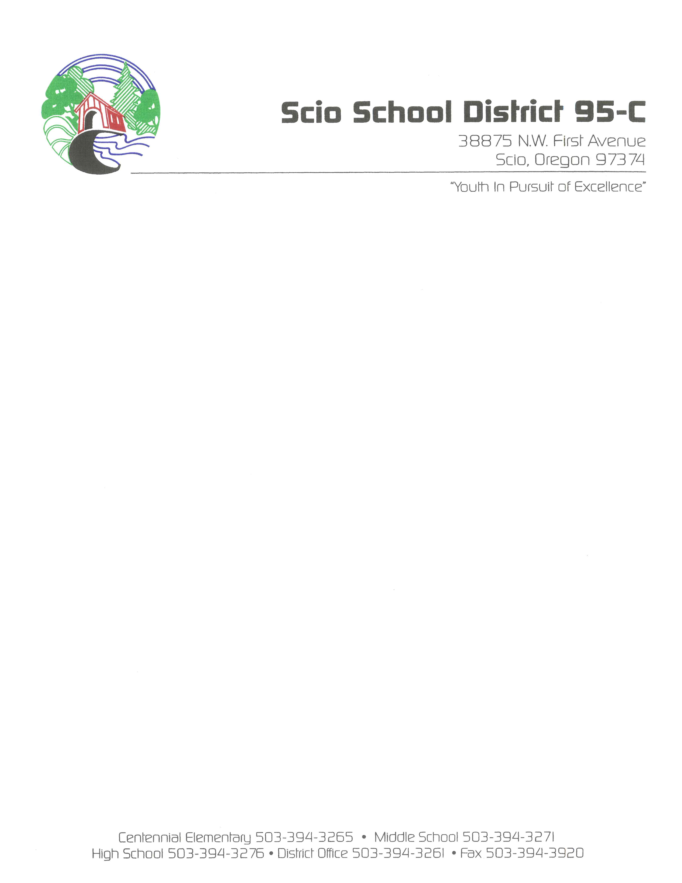

SCHOOL BOARD MEETINGS
CENTENNIAL LIBRARY
38875 NW FIRST AVENUE
Thursday, August 18, 2022
7:00 P.M.
In Person/Online - Via ZOOM
https://scio.k12.or.us/board/online/

6:00 P.M. Executive Session – This meeting will be held in the Scio School District Office at 38875 N.W. 1st Ave., Scio, Oregon. Called according to ORS 192.660(2)(a) to consider employment and (2)(i) to evaluate staff performance; ORS 192.660 (2)(f) to consider records that are exempt by law from public inspection; ORS 192.660(2)(d) labor negotiations; ORS 332.061(1) to conduct a hearing on student behaviors or to review student records; 192.660(2)(b) to consider the dismissal or disciplining of, or to hear complaints or charges brought against, a public officer, employee, staff member or agent; ORS 192.660(2)(h) to consult with counsel concerning the legal rights and duties of a public body with regard to current litigation or litigation likely to be filed.

7:00 P.M. Regular Board Meeting Agenda
- Call to Order/Welcome
  - Salute Chairman, Kerri Hyde
  - Audience Introductions/Request
  - Approval of Consent Agenda
    - Regular Board Meeting Minutes Superintendent, Steve Martinelli
    - Regular Executive Session Minutes Superintendent, Steve Martinelli
    - Check Listing & Other Disbursements Report 07/31/2022 Superintendent, Steve Martinelli
    - Financial Summary for period ending 07/31/2022 Superintendent, Steve Martinelli
    - Transportation Report for period ending 07/31/2022 Superintendent, Steve Martinelli
    - Resignations Superintendent, Steve Martinelli
  - Adjust to Agenda/Adopt Agenda

- Delegation / Visitors
Visitor/patron comments that do not meet the two-week requirement to be placed on the agenda may be heard. Such unplanned comments will be limited to (3) minutes per person with a maximum of 30 minutes’ total discussion, for any given item.

  - Visitor/Patron Comments

- Items Requiring Board Action
  - Staff Changes: Hiring’s and Retirements Superintendent, Steve Martinelli
  - Adjustments to the School District Calendar Superintendent, Steve Martinelli

- Items for the information of the Board
  - Superintendent’s Report Superintendent, Steve Martinelli
  - GT Report Director of Charter Schools, Gary Tempel

- Board Comments/Information

- Announcements/Date of Importance

Regular Board Meeting, Thursday September 22, 2022, at High School Library

- Adjournment

