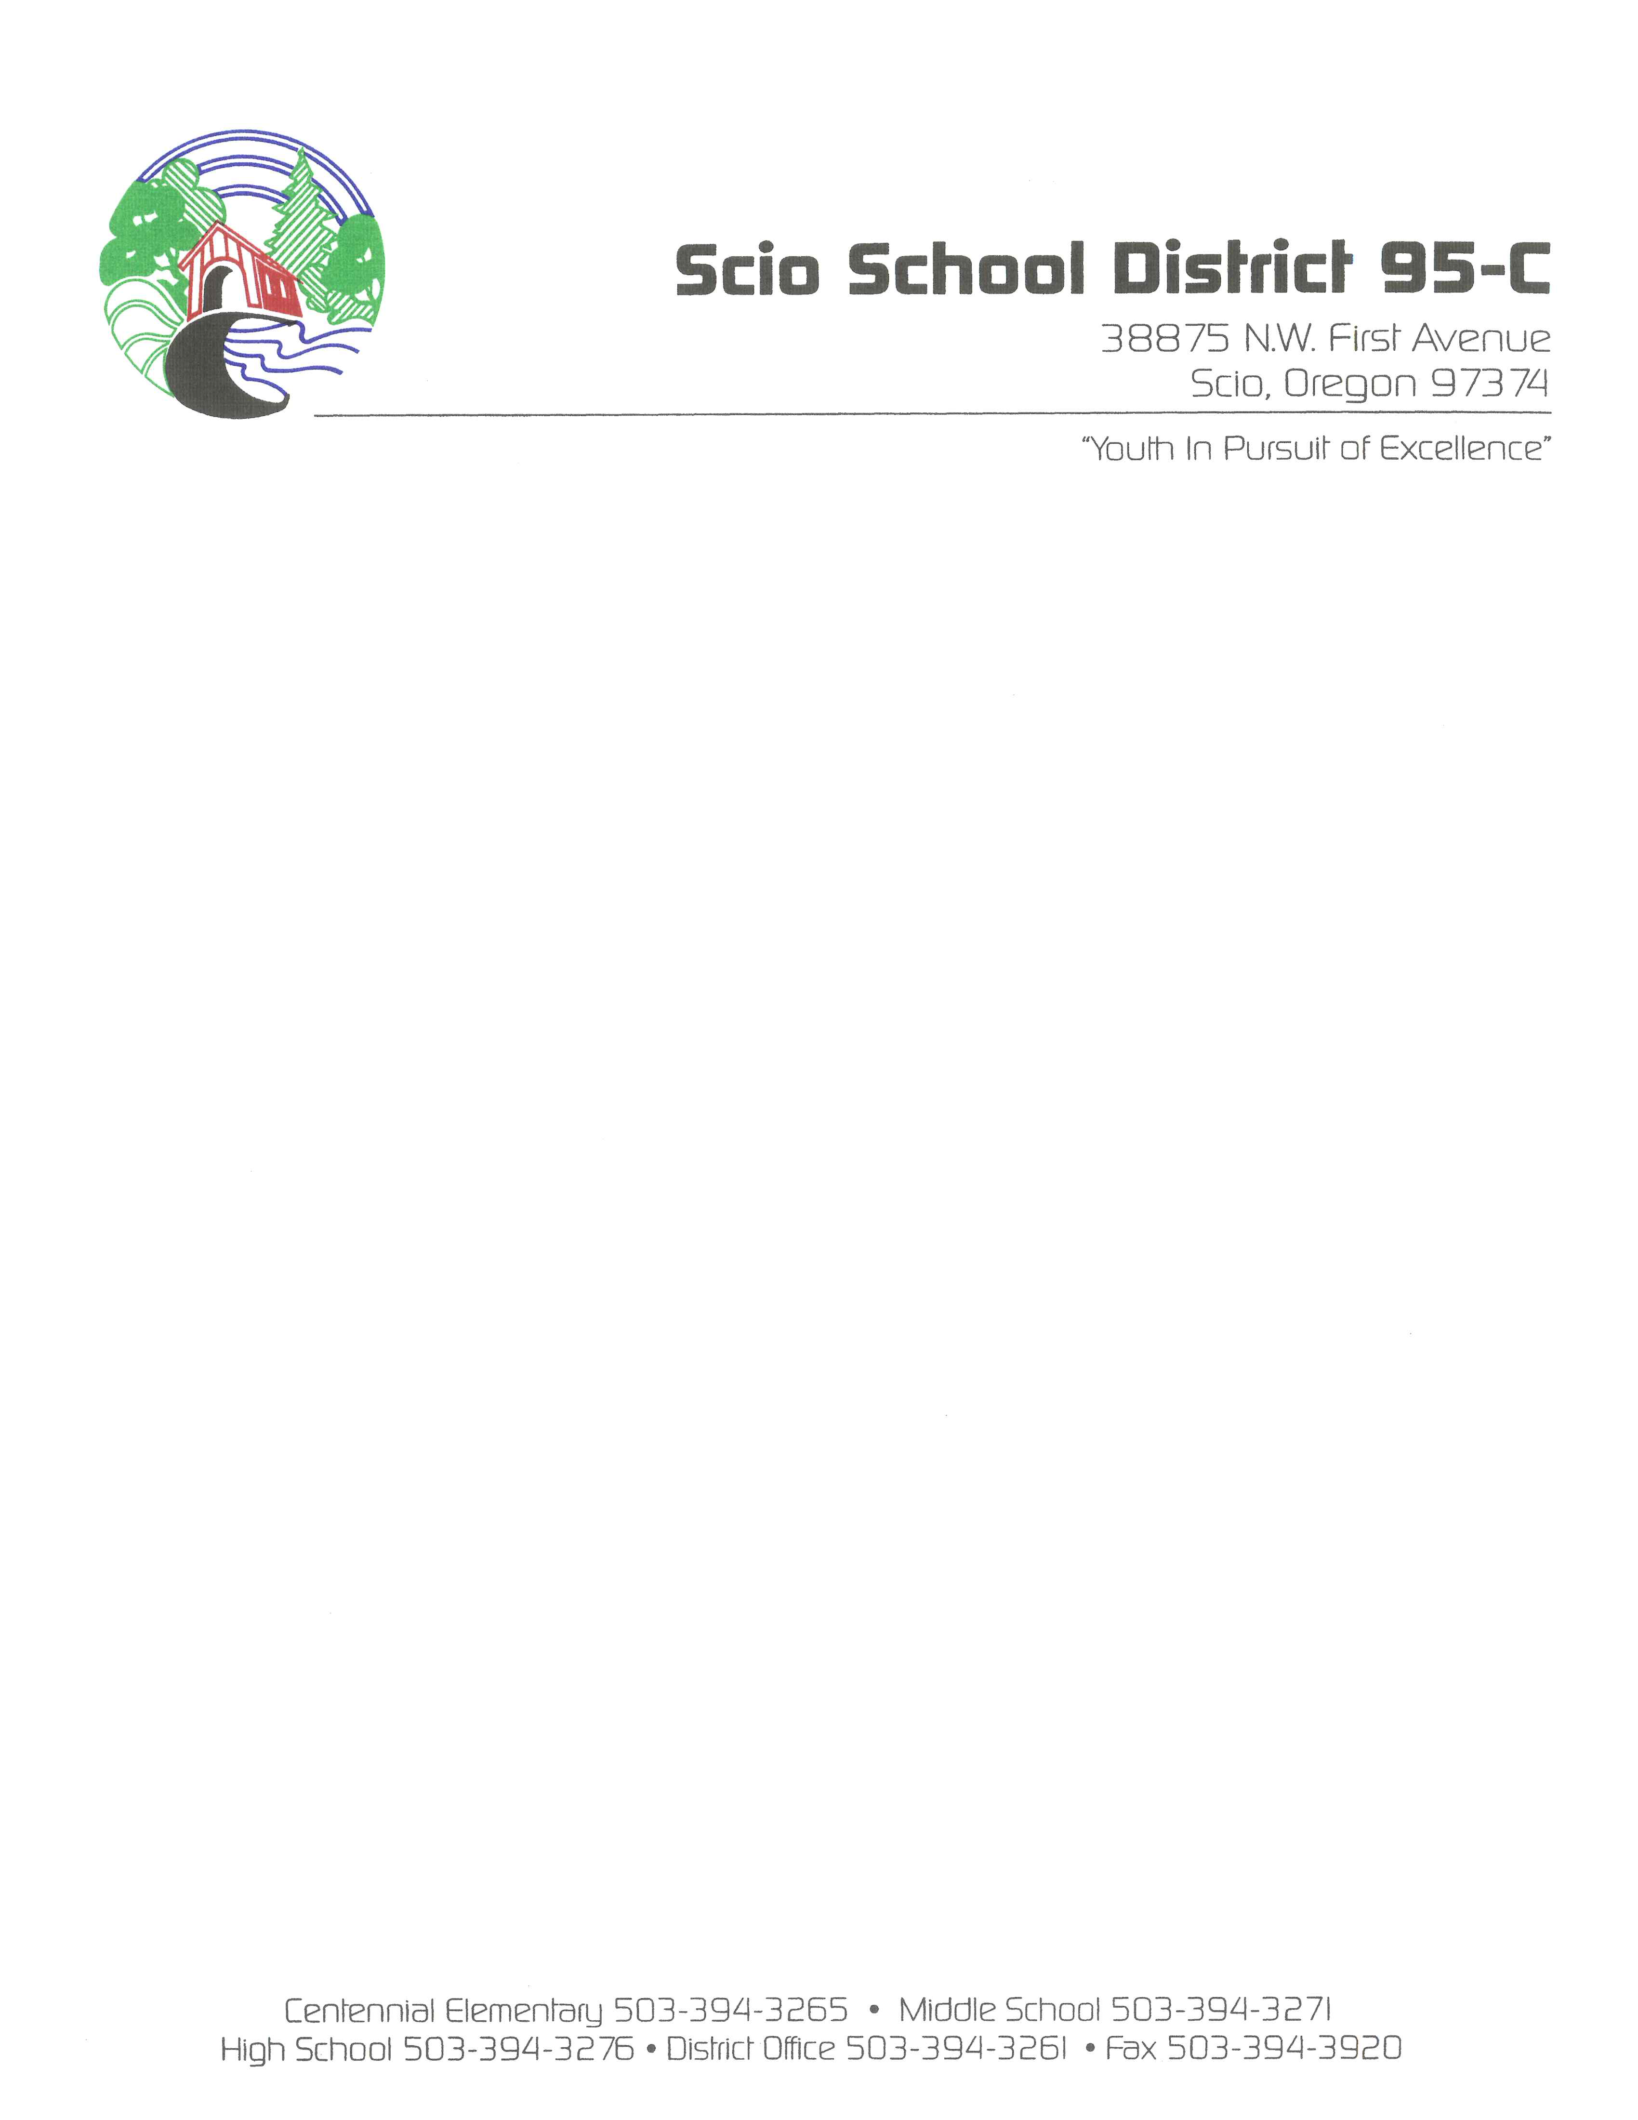

SCHOOL BOARD MEETINGS
MIDDLE SCHOOL LIBRARY
38875 NW FIRST AVENUE
May 19, 2021
7:00 P.M.
In Person/Online - Via ZOOM

6:00 P.M. Executive Session – This meeting will be held in the Scio School District Office at 38875 N.W. 1st Ave., Scio, Oregon. Called according to ORS 192.660(2)(a) to consider employment and (2)(i) to evaluate staff performance; ORS 192.660 (2)(f) to consider records that are exempt by law from public inspection; ORS 192.660(2)(d) labor negotiations; ORS 332.061(1) to conduct a hearing on student behaviors or to review student records; 192.660(2)(b) to consider the dismissal or disciplining of, or to hear complaints or charges brought against, a public officer, employee, staff member or agent; ORS 192.660(2)(h) to consult with counsel concerning the legal rights and duties of a public body with regard to current litigation or litigation likely to be filed.

In light of the COVID-19 state-wide restrictions and in keeping with the efforts of social distancing to reduce the spread of the coronavirus, the Scio School District Board of Directors will meet in person rather than online. Members of the public will be virtually online, rather than in person and can access the livestream feed of the meeting by clicking the link below which will redirect you to our website giving you instructions on how to get access.

https://scio.k12.or.us/board/online/

7:00 P.M. Regular Board Meeting Agenda
- Call to Order/Welcome
  - Salute Chairman, Doug Parazoo
  - Audience Introductions/Request
  - Approval of Consent Agenda
    - Regular Board Meeting Minutes Superintendent, Steve Martinelli
    - Regular Executive Session Minutes Superintendent, Steve Martinelli
    - Scio School Board Retreat Minutes Superintendent, Steve Martinelli
    - Special Executive Session Minutes 04/17/2021 Superintendent, Steve Martinelli
    - Check Listing & Other Disbursements Report 04/30/2021 Superintendent, Steve Martinelli
    - Financial Summary for period ending 04/30/2021 Superintendent, Steve Martinelli
    - Transportation Report for period ending 04/30/2021 Superintendent, Steve Martinelli
    - Resignations Superintendent, Steve Martinelli

  - Adjust to Agenda/Adopt Agenda
  - Spot Light on Education Scio Middle School

- Delegation / Visitors
Visitor/patron comments that do not meet the two-week requirement to be placed on the agenda may be heard. Such unplanned comments will be limited to (3) minutes per person with a maximum of 30 minutes’ total discussion, for any given item.
  - Staff Reports Staff Members
  - High School/Middle School Leadership Representative
  - Visitor/Patron Comments

- Items Requiring Board Action
  - Staff Changes: Hiring’s and Retirements Superintendent, Steve Martinelli
  - Approval of OEA Contract Superintendent, Steve Martinelli
  - Out of State Travel-HS Cheer Camp Cheerleading Coach, JaAnna Mendez
  - STEM-CTE Grant Superintendent, Steve Martinelli
  - Purchase of New Big Bus Superintendent, Steve Martinelli
  - Purchase of New Mini Bus Superintendent, Steve Martinelli
  - Middle School Baseball/Softball Dugouts Superintendent, Steve Martinelli
  - Middle School Handbook Changes Principal, Greg Nolan

- Items for the information of the Board
  - Superintendent’s Report Superintendent, Steve Martinelli
  - GT Report Director of Charter Schools, Gary Tempel
  - School Reports
    - Centennial Elementary School Principal, Kim Roth
    - Scio Middle School Principal, Greg Nolan
    - Scio High School Principal, Dani Blackwell

- Board Comments/Information

- Announcements/Date of Importance

If needed - Scio School District Budget Committee Meeting, Thursday May 27, 2021 @ 7 pm

Regular Board Meeting, Wednesday June 16, 2021

- Adjournment

